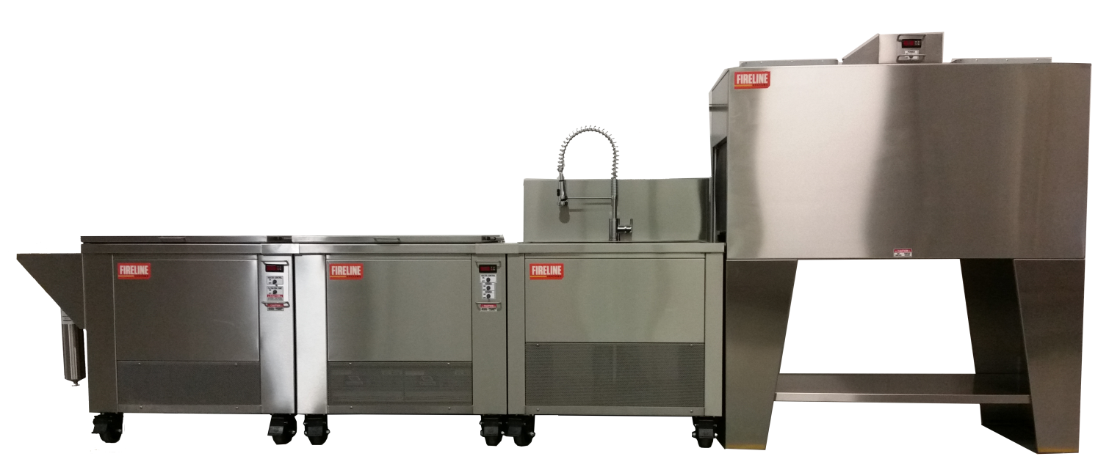
The FIRELINE C-4 Compact Plus consists of a pre-washer, ultrasonic cleaner, rinse station and inline dryer. All processing stations operate independently from one another or can be locked together forming a single continuous production line. The C-4 processes 8 parts baskets simultaneously. (110v & 220v operation).

C-4 Pre-Washer:
Pre-washer ID tank dimensions are 30” x 22” x 20"D. Dual stainless washer bars provide a gentle and effective cyclonic wash activity which quickly removing initial heavy residues from content items. The C-4 also features a filtering system, onboard heater with digital controller, all stainless steel construction with insulated lid and heavy-duty locking casters.
Overall Dimensions 46.5"L x 35.5” W x 35" H

C-4 1800 Ultrasonic Processor
The ultrasonic cleaner ID tank dimension is 30” x 22” x 20. The C-4 1800 SCU ultrasonic cleaner is powered by 2-900 W Sonicpro ultrasonic generators featuring Dynamic Wave Sweep circuitry which effectively eliminating standing waves and dead zones from the cleaning bath. Other features include all stainless steel construction, insulated lid, heavy-duty locking casters.
Overall Dimensions 36"L x 35.5” W x 35" H

C-4 RS 2400 Rinse Station
The RS 2400 rinse station's ID sink dimension are 30” x 22” x 20". This oversize mobile rinse station accommodates two parts baskets simultaneously. The RS 2400 comes with stainless steel basket rack to elevate parts baskets during the rinsing process. The RS 2400 features a premium Danze commercial faucet, all stainless steel construction and heavy-duty locking casters.
Overall Dimensions 36"L x 35.5” W x 35" H

C-4 Contents Dryer
ID dryer dimensions are 57”L x 24”W . This unique dryer speeds up the production process. The C-4 blower delivers preheated air via two high powered overhead dryers. A conveyor roller pass through design decreases drying time. Drying chamber temperature is regulated by a front mounted digital controller and this unit runs off a 220 V 30 amp circuit. Other features
include all stainless steel construction.

